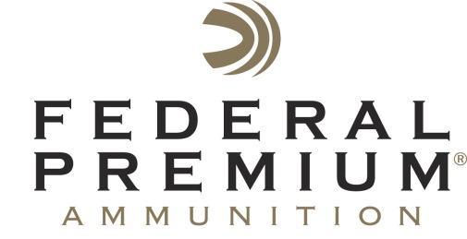
Contact: JJ Reich
Public Relations Specialist
763-323-3862
FOR IMMEDIATE RELEASE E-mail: pressroom@atk.com

Federal Premium® Ammunition Presents Fresh Tracks with Randy Newberg

Federal Premium® Ammunition is the title sponsor for Fresh Tracks with Randy Newberg which debuts in July on Sportsman Channel. This all-new program features expert hunter Randy Newberg. It takes viewers through a season-long journey, showing the amazing self-guided hunts on public land that are available to any American. Every episode is a story of passion and commitment, determination and struggle; and in the end, a story that reflects how hunting and life occur for most hunters.

ANOKA, Minn. – July 2, 2013 – Federal Premium® Ammunition is pleased to announce its title sponsorship of Fresh Tracks with Randy Newberg. The all-new TV program will debut on Sportsman Channel in July. The series is hosted by Randy Newberg from On Your Own Adventures. He is one of the most accomplished and knowledgeable public-land hunters in America. Fresh Tracks continues the self-guided public land hunting theme that fans have come to love in On Your Own Adventures, yet tells that story in a deeper and more personal format.

“This is a new style and new format for telling the story of the American hunter,” Newberg said. “For an entire season, viewers will follow our crew as they travel to vast tracts of amazing public lands in the United States, facing all the challenges that come with self-guided hunting. We let the viewer see it all, successful or not. We are not only hunters while in the field; we are also hunters year-round in our advocacy and conservation work.”

Newberg illustrates the lifestyle of the American hunter, living his passion all day, every day, whether at home, in the field, or on the road, and bringing that story to the viewer with new hunts every week. Everyday hunters can relate to this new program because it shows everything that happens in a season: the hits and the misses.

“Hunting in America is an amazing story that needs to be told in all aspects, when things go good or when they go bad,” Newberg said. “This is my story, and it’s very personal. It’s full of passion and commitment.”

All-new episodes of Federal Premium’s Fresh Tracks with Randy Newberg start in July on Sportsman Channel. The show airs Thursday at 8:00 p.m. and 11:00 p.m., Friday at 6 a.m., and Tuesday at 9:00 a.m. (EST).

About Fresh Tracks with Randy Newberg
The show takes viewers through a year in the life of one of America’s most dedicated, hard-core hunters–someone who lives hunting 24/7. Follow Randy on action-packed, extreme public land hunts and learn the dedication, work and passion it takes to complete these amazing adventures. Preparing gear, scouting and research, all combine with the complications of TV production. Learn more about Fresh Tracks with Randy Newberg by visiting www.thesportsmanchannel.com.

About Federal Premium
Headquartered in Anoka, Minnesota, Federal Cartridge Company has been providing hunters and shooters with high-quality rimfire, centerfire and shotshell ammunition since 1922. It pioneered the Premium category of ammunition and is part of the world's leading ammunition manufacturer, ATK Sporting. For more information on Federal Premium products visit www.federalpremium.com.

